DIGITAL LOGIC DESIGN
Practice Questions 3
Q1. Design the logic diagram for 3-bit Asynchronous up counter J-K flip-flops. Draw the output waveforms. Explain how can we use the same logic diagram to consider it as the down counter?

Q2. State the steps how can you convert SR flip flop into a T flip flop. Solve and draw the logic diagram.

Q3. Latches & Flip flops
- Briefly explain the difference between a latch and a flip flop?
- Why flip flops are preferred over latches?
- How latches are modified to work as flip flops?
Q4. Consider the clock, S, R inputs as waveforms. These are applied to two SR flip flops (+ve edge triggered & -ve edge triggered) and one SR latch. You are required to draw output waveforms for each case separately.

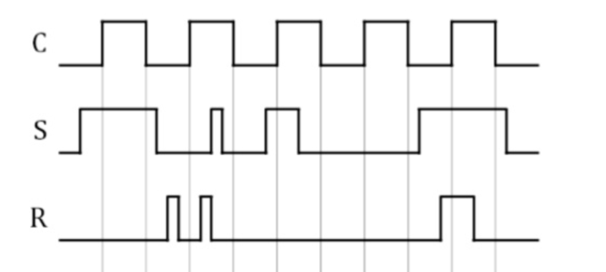

Q5. The waveforms in the following figure are applied to J, K and clock inputs as indicated. Determine the Q output assuming that Flip flop is initially Reset.

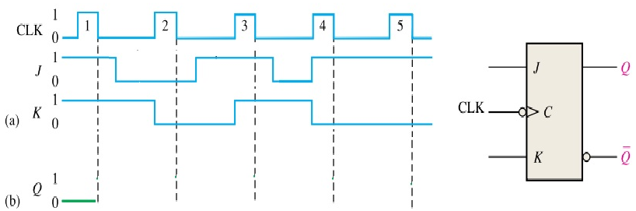

Q6) Design a sequential circuit with three SR flip-flops A(Q₂), B(Q₁) and C(Q₀) and one input X. When X=0, the state of the circuit remains the same. When X=1, the circuit goes through the state transitions from 000 to 001 to 010 to 011 to 100 to 101 to 110 to 111 and back to 000, and then repeats. Draw the logic diagram for the circuit (after applying all the steps).
Q7) Design a frequency divider circuit using JK flip-flops. A 1 kHz clock signal is applied to the input. The first module should divide the frequency down to 250 Hz, and the second module should further divide it to 62.5 Hz. Determine the number of JK flip-flops required for each stage, draw the complete logic diagram, and explain how the output frequencies are achieved step by step.

